

To: Professor Osama Alshaykh and Professor Alan Pisano

From: Caroline Jones, Sneha Pradhan, Michael Haley, Tanatsigwa Hungwe, and Zehua (Harry) Zhao

Team: 1

Date: April 30th, 2017

Subject: **Hardware Readme**

**___________________________________________________________________________________________**



1. **Overall Description**

1.1 The Luminesense system consists of five major modules: the wearable transceiver, the central base, the luminaires, the single pixel cameras, and the web application. Their integration amongst each other and utility depends on the current mode of engagement - “gesture mode” or “adaptive mode”. The following README concerns the hardware components only.

**2.0 Schematics**

2.1 Wearable Transceiver

The transceiver consists of the following: an Arduino 101 and an embedded circuit - a 6-axis IMU, a Bluetooth Low Energy (BLE) module, a photodiode, three push buttons, and a battery pack. This device is responsible for all interactions between the user and the system (in gesture mode).

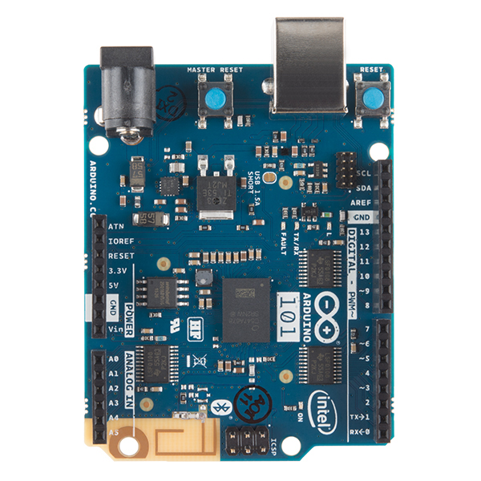

2.1.1 **Arduino 101**

Requires Arduino IDE to build/develop software. This IDE application can be found at <https://www.arduino.cc/>. The appropriate libraries need to be downloaded in order to use the boards’ functions. Board is powered either via USB or using the battery pack. In order to run the specific functions such as BLE, FFT an IMU functionality, certain libraries must be utilized: fft_2.h, CurieIMU.h, CurieBLE.h, and math.h. The functionality of these will be further explained in the *Software Readme.docx* document.

Technical Specifications:

|  |  |
| --- | --- |
| Microcontroller | Intel Curie |
| Operating Voltage | 3.3V (5V tolerant I/O) |
| Input Voltage (recommended) | 7-12V |
| Input Voltage (limit) | 7-17V |
| Digital I/O Pins | 14 (of which 4 provide PWM output) |
| PWM Digital I/O Pins | 4 |
| Analog Input Pins | 6 |
| DC Current per I/O Pin | 20 mA |
| Flash Memory | 196 kB |
| SRAM | 24 kB |
| Clock Speed | 32MHz |
| LED_BUILTIN | 13 |
| Features | Bluetooth LE, 6-axis accelerometer/gyroscope |
| Length | 68.6 mm |
| Width | 53.4 mm |
| Weight | 34 gr. |
| Vendor | **https://store.arduino.cc/usa/arduino-101** |
| Price | $30.00 |

2.1.2 **Embedded Circuit**

**Operational Amplifier**



Technical Specifications: see attached GitHub resource pdf in Resource GitHub folder or link:

**http://www.ti.com/lit/ds/symlink/lm741.pdf**

Vendor: **http://www.ti.com/product/LM741**

**Photodiode**

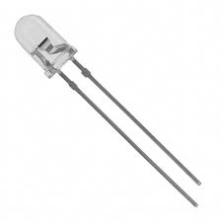

Necessary to sample analog signals during FFT processing. This must be connected to A1 port of the Arduino 101 for ADC conversions.

Technical Specifications:

|  |  |
| --- | --- |
|  |  |
| Manufacturer: | Osram Opto Semiconductor |
| RoHS: | RoHS Compliant Details |
| Product: | PIN Photodiodes |
| Package / Case: | T-1 |
| Mounting Style: | Through Hole |
| Peak Wavelength: | 860 nm |
| Dark Current: | 50 pA |
| Vr - Reverse Voltage: | 20 V |
| Rise Time: | 10 ns |
| Fall Time: | 10 ns |
| Half Intensity Angle Degrees: | 17 deg |
| Maximum Operating Temperature: | + 100 C |
| Minimum Operating Temperature: | - 40 C |
| Brand: | OSRAM Opto Semiconductors |
| Height: | 5.2 mm |
| If - Forward Current: | 100 mA |
| Length: | 4 mm |
| Noise Equivalent Power - NEP: | 0.65E-14 W/sqrt Hz |
| Packaging: | Bulk |
| Pd - Power Dissipation: | 150 mW |
| Photocurrent: | 28 uA |
| Responsivity: | 0.62 A/W |
| Factory Pack Quantity: | 2000 |
| Vf - Forward Voltage: | 1.3 V |
| Width: | 3 mm |
| Price: | $0.0584 |

**Buttons**

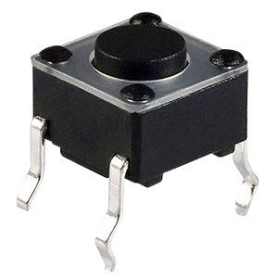

Three buttons will be used to control different interaction between user and the system. Each button connected to a PWM port of the Arduino 101 (pins 2, 4, 6).

|  |  |
| --- | --- |
| **Product Category:** | Tactile Switches |
| **Manufacturer:** | TE Connectivity |
| **RoHS:** | RoHS Compliant Details |
| **Mounting Style:** | SMD/SMT |
| **Mounting Direction:** | Vertical |
| **Actuator:** | Round |
| **Current Rating:** | 50 mA |
| **Voltage Rating DC:** | 24 VDC |
| **Termination Style:** | Gull Wing Lead |
| **Packaging:** | Reel |
| **Brand:** | TE Connectivity / Alcoswitch |
| **Factory Pack Quantity:** | 1200 |
| **Vendor** | **http://www.mouser.com/ProductDetail/TE-Connectivity-Alcoswitch/FSM2JSMAATR/?qs=sGAEpiMZZMvbyeSUH4qH%2fH49a3du0w9x** |
| Price: | $0.0247 |

**Battery**

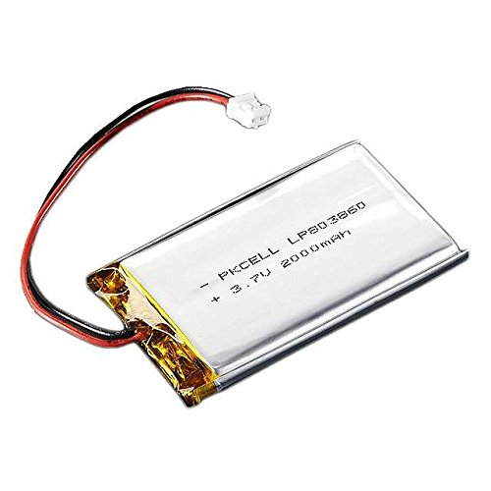

Technical Specifications:

Dimensions: 60mm x 36mm x 7mm / 2.4" x 1.4" x 0.3"

Weight: 34 grams

Nominal Capacity: 2000mAh ±2%

Nominal Voltage: 3.7V

Standard Charge Current: ~0.2C / 0.5A

Charge Cut-Off Voltage: 4.2V

Overuse Cut-Off Voltage: 3.0V

Cell-Type: Lithium Ion

Standard Discharge Current: ~0.2C / 0.5A

Price: $18.99

2.1.3 **Case**

The case is a combination of 3 parts: Arduino case, watch band, and a 3D printed middle extension. The actual .STL file is attached in the Resource GitHub folder and can be viewed on using CAD software program. Below is the file rendered as an image file.

*Figure 1: 3D casting of case middle extension*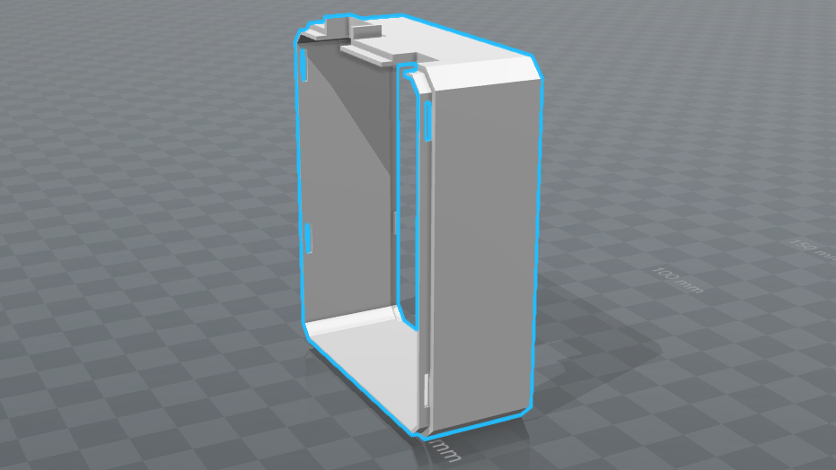

Technical Specifications:

**Arduino Case**

Dimensions: 3.2" x 2.5" x 1.2"

Weight: 39.7 grams

Manufacturer: SB Components Ltd

**Middle Extension**

Dimensions: 3.2" x 2.5" x 1"

Weight: 31.5 grams

CAD software: Solidworks 2016

**Watch band**

Band width: 24 mm

Band Length: 279.4 mm

Band Material: Nylon

2.2 **Central Base**

2.2.1 **Raspberry Pi 3**

In order to setup up the Pi initially: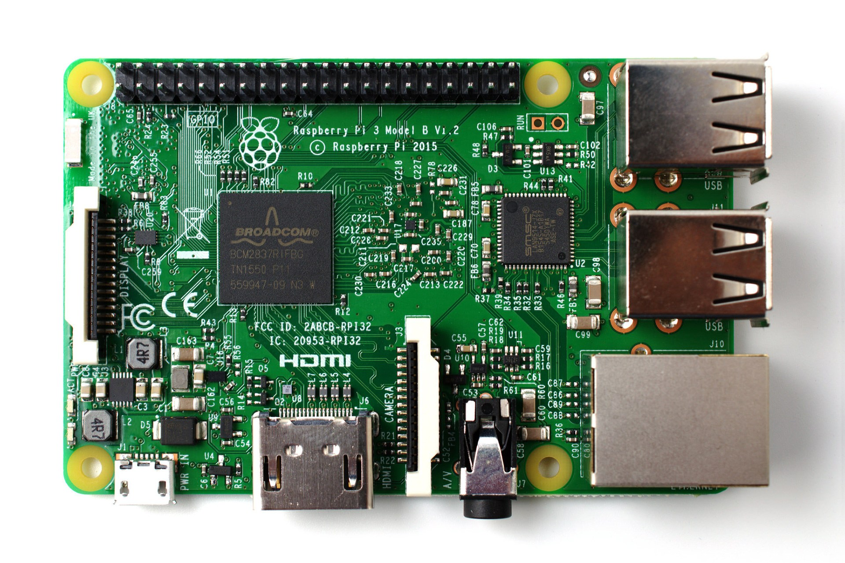

* Buy and insert a microSD card of minimum 8GB.
* Using a computer with an SD card reader, visit the **https://www.raspberrypi.org/downloads/noobs/** page.
* Click on NOOBS, then click on the Download ZIP button under ‘NOOBS (offline and network install)’, and select a folder to save it to.
* Extract the files from the zip.
* Visit the [SD Association’s website](http://www.sdcard.org/) and download [SD Formatter 4.0](https://www.sdcard.org/downloads/formatter_4/) for either Windows or Mac.
* Follow the instructions to install the software.
* Insert your SD card into the computer or laptop’s SD card reader and make a note of the drive letter allocated to it, e.g. G:/
* In SD Formatter, select the drive letter for your SD card and format it.
* Once your SD card has been formatted, drag all the files in the extracted NOOBS folder and drop them onto the SD card drive.
* The necessary files will then be transferred to your SD card.
* When this process has finished, safely remove the SD card and insert it into your Raspberry Pi.
* Plug in your keyboard, mouse, and monitor cables.
* Now plug the USB power cable into your Pi
* Your Raspberry Pi will boot, and a window will appear with a list of different operating systems that you can install. We recommend that you use Raspbian – tick the box next to Raspbian and click on Install.
* Raspbian will then run through its installation process. Note that this can take a while.
* When the install process has completed, the Raspberry Pi configuration menu (raspi-config) will load. Here you are able to set the time and date for your region, enable a Raspberry Pi camera board, or even create users. You can exit this menu by using Tab on your keyboard to move to Finish.
* The default login for Raspbian is username *pi* with the password *raspberry*. Note that you will not see any writing appear when you type the password. This is a security feature in Linux.
* To load the graphical user interface, type *startx* and press Enter.
* Subsequently you must install *noble*, *particle-api-js*, and *pg* via the sudo apt get method
* The are responsible for the Bluetooth Low Energy, Particle photon calls, and database querying and posting methods respectively. These are used by the RasPi to aggregate data and issue commands.

Technical Specifications:

A 1.2GHz 64-bit quad-core ARMv8 CPU

802.11n Wireless LAN

Bluetooth 4.1

Bluetooth Low Energy (BLE)

1GB RAM

4 USB ports

40 GPIO pins

Full HDMI port

Ethernet port

Combined 3.5mm audio jack and composite video

Camera interface (CSI)

Display interface (DSI)

Micro SD card slot (now push-pull rather than push-push)

VideoCore IV 3D graphics core

2.2.2 **Router**

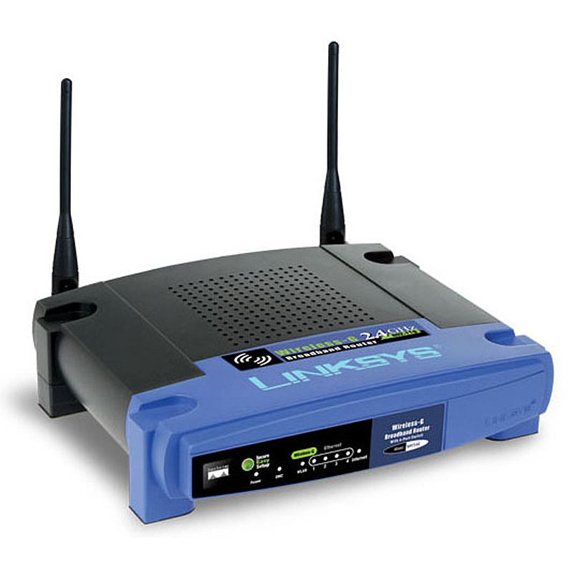

Setups up the wireless network for the Photons and Raspberry Pi. This is powered to 12V via a power cable. This spoofs Boston University’s 802.1x Wi-Fi for the Photons to exist within the system.

|  |  |
| --- | --- |
| **RAM** | 2000000 MB |
| **Wireless Type** | 802.11 B/G |
| **Brand Name** | Linksys |
| **Series** | WRT54GL |
| **Item model number** | WRT54GL |
| **Operating System** | N/A |
| **Item Weight** | 1.6 pounds |
| **Product Dimensions** | 9.8 x 10 x 2.8 inches |
| **Item Dimensions L x W x H** | 9.75 x 10 x 2.8 inches |
| **Color** | Blue / Black |
| **Computer Memory Type** | DRAM |
| **Power Source** | AC Power Adapter |
| **Vendor** | **https://www.amazon.com/Linksys-WRT54GL-Wireless-G-Broadband-Router/dp/B000BTL0OA/ref=sr_1_4?ie=UTF8&qid=1493597056&sr=8-4&keywords=router+linksys** |
| **Price** | $35.49 |

2.3 **Luminaire**

2.3.1 **Particle Photon**

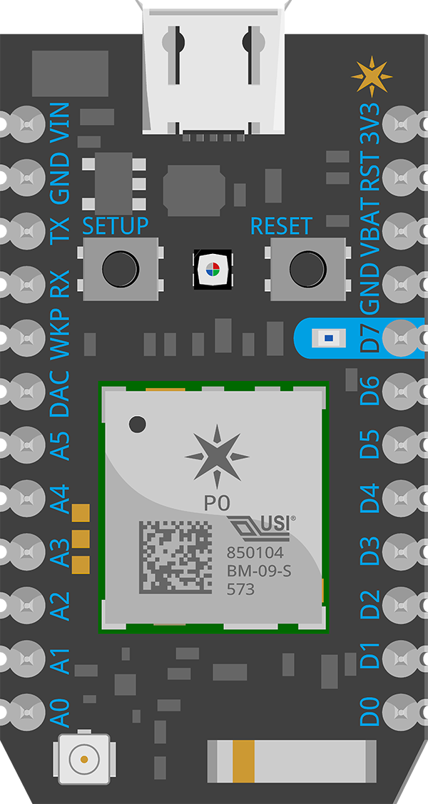

Requires initialization on the command line. This requires Node.js version of at least 6.0.0. Once installed, you can initialize Photons to desired networks and create an account on the web IDE at **build.particle.io/build**. Here is where all the code development is done on the Photons. The Photons are powered via USB same way as the Arduino.

|  |  |
| --- | --- |
| **RAM** | 128 KB |
| **Wireless Type** | 802.11b/g/n |
| **Operating System** | 120Mhz ARM Cortex M3 |
| **Flash** | 1MB |
| **Power** | 3.6V - 5.5V |
| **Item Weight** | 0.0110231 pounds |
| **Product Dimensions** | 9.8 x 10 x 2.8 inches |
| **Item Dimensions L x W x H** | 1.44 x 0.8 x 0.27 inches |
| **Color** | Blue / Black |
| **Power Source** | AC Power Adapter |
| **Vendor** | **https://store.particle.io/products/photon** |
| **Price** | $19.00 |

2.3.2 **Lighting fixture (Cree XLamp MC-Color)**

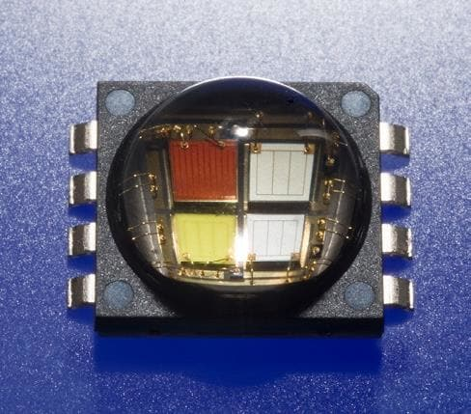

Technical Specifications and schematic: see in attached Resource GitHub pdf in folder or link [**http://www.mouser.com/ds/2/90/XLampMCE-270569.pdf**](http://www.mouser.com/ds/2/90/XLampMCE-270569.pdf)

2.4 Single Pixel Camera

Raspberry Pi will sample each of the 12 single pixel sensor values for “red”, “blue”, “green”, “clear”, and time duration ~10 times/second.

To access Sensor Driver and launch adaptive mode detection:

1. Instructions for installing MQTT broker on your machine is OS dependent. Install Apache ActiveMQ broker on local machine from their website.

2. Once downloaded cd to directory where broker is installed and run command “activemq start”

2. Connect to SLURP raspberry pi network by connecting to ethernet in back room of lab.

3. SSH to SLURP raspberry pi (IP: 192.168.1.202 Username: pi Password: ercraspberry)

4. Go to the raspberry pi driver folder - cd doug/UROP_SinglePixelLocalization/raspberryPi-drivers

5. Run python MQTT_adapt.py -- host 192.168.1.XXX -- time 100 -- gain 60

-host is the IP address of your MQTT broker

If successful, the room ON/OFF state and any motion detection will be indicated in console

To quit adaptive mode: exit terminal or Ctrl-C on Keyboard

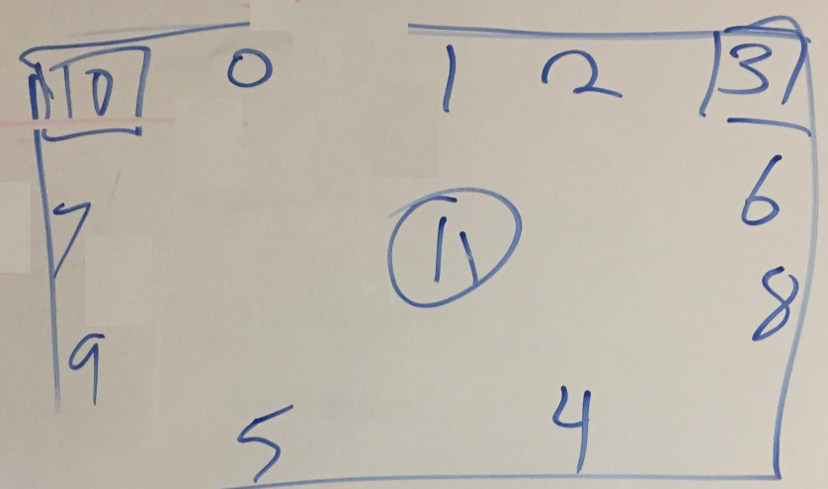

*Figure 2: Arrangement of 12 Single Pixel Sensors in SLURP, 10 is at entrance (circa February 2017)*

**3.0 Setup**

3.1 **Overall Arrangement**

The overall setup consists of the above described components connected via different setups. However there are two important initial steps:

**Step 1: Configure network**

The user must connect the router in the central base to their network using a standard ethernet cable. This central base must be placed in close proximity of the system in order to ensure a strong bluetooth connection between the base and the wearable. Additionally, the user must ensure that the Raspberry Pi is connected to the router via an ethernet cable. Initialize the single pixel cameras by connecting to LAN via ethernet. Connect to the local Raspberry Pi directory via ssh and run the MQTTMux2.py file. This launches adaptive mode passive detection.

**Step 2: Power components**

Connect the router, Raspberry Pi and cameras to standard outlets. The Raspberry Pi will boot to the default program and begin scanning for the wearable’s BLE peripheral address. To power the wearable, the user must push the switch on the battery to the “on” position. The wearable’s LED will flash green if successful. If the wearable does not power up, then the user must charge the battery using the included USB cable. Once the wearable has been securely strapped to the wrist and powered on, the user may begin to interface with the system.

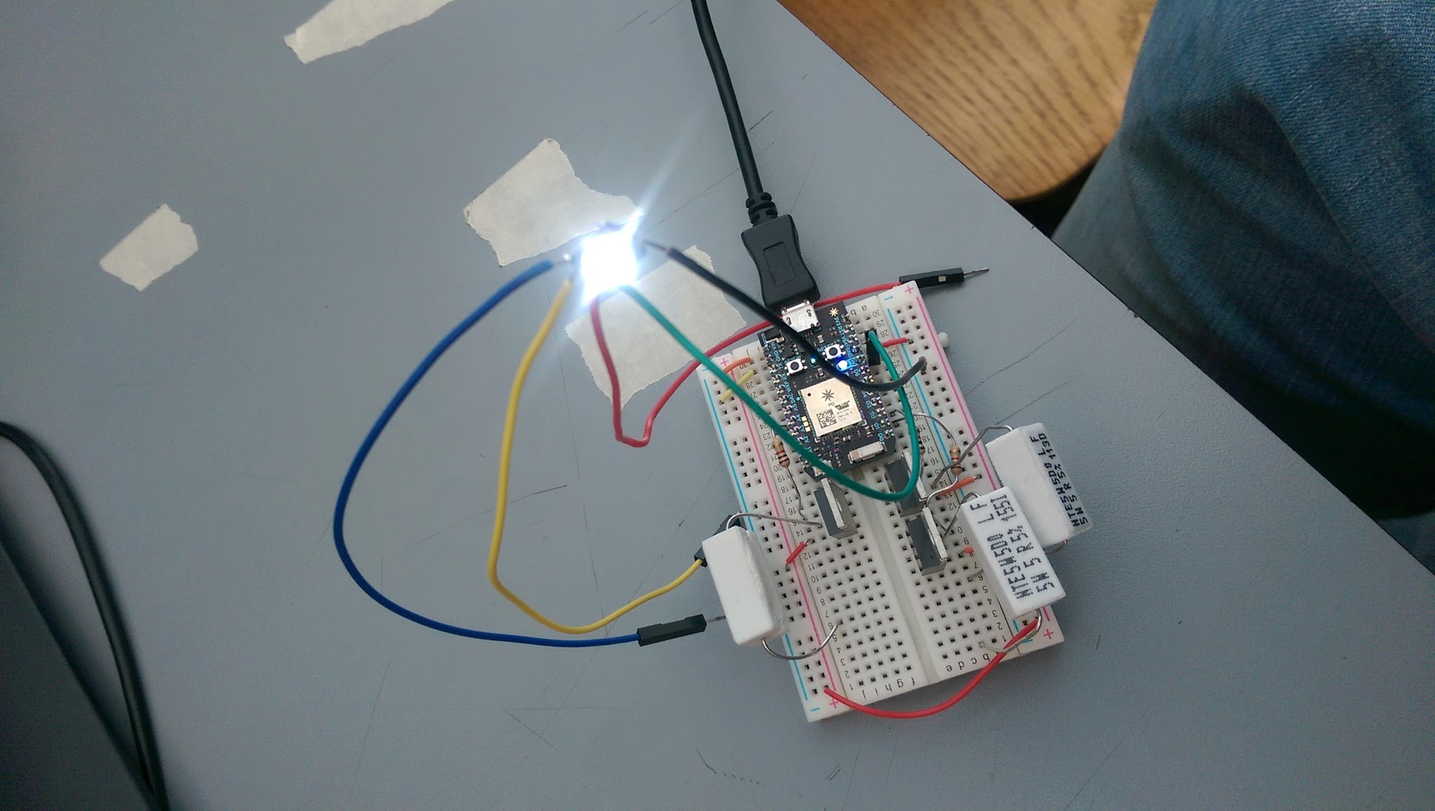

*Figure 3: Early hardware setup: Photon and* Cree XLamp MC-Color *(circa October 2016)*

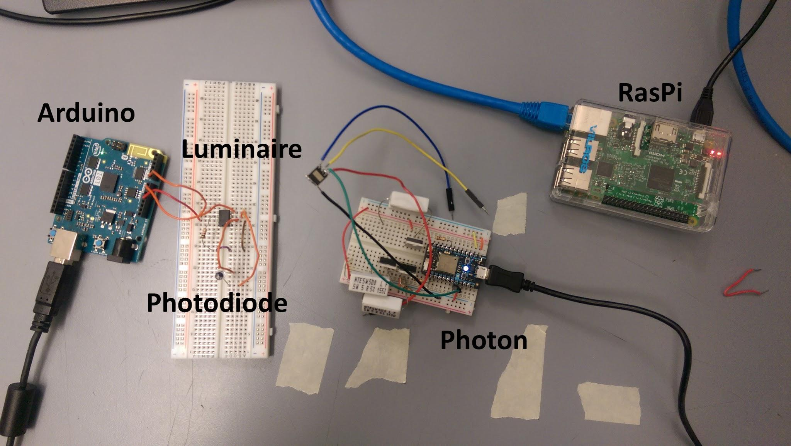

*Figure 4: Overall system setup (circa November 2016)*

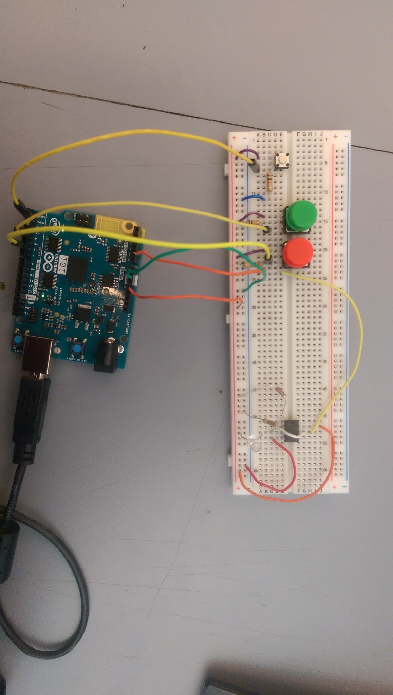

*Figure 5: Photodiode Amplifier circuit with peripherals (circa February 2017)*

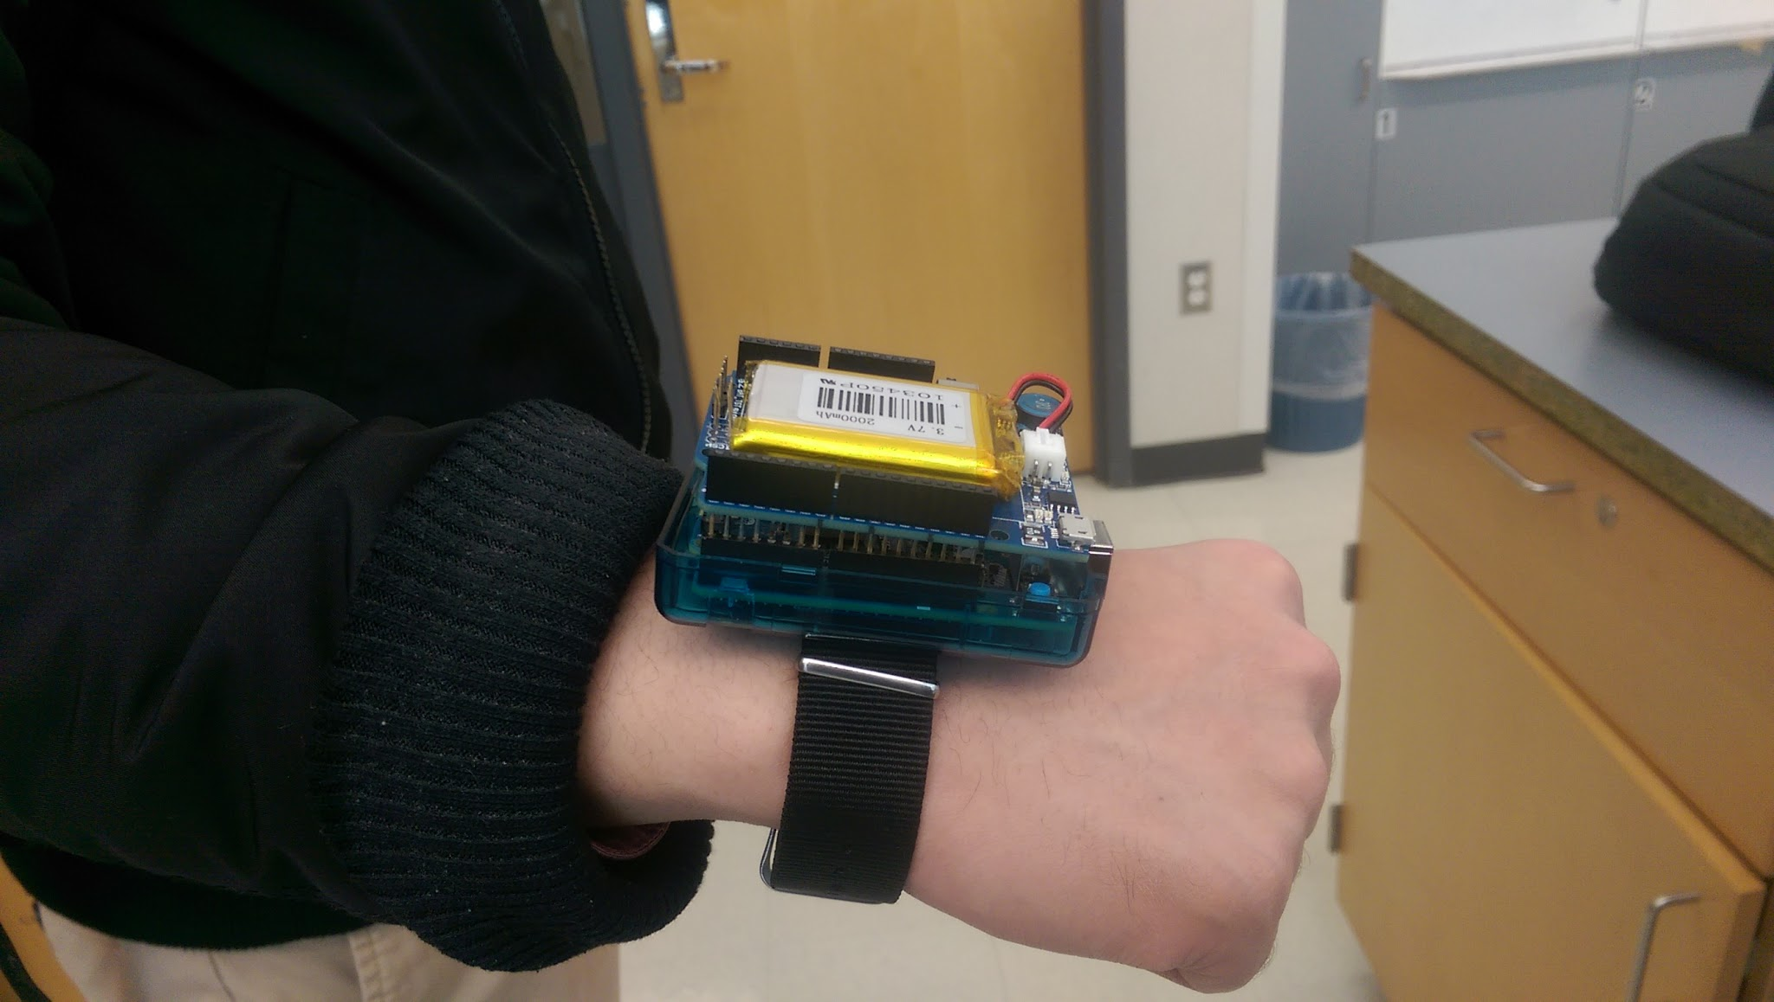

*Figure 6: The wearable design fitted with the battery and strap (circa February 2017)*

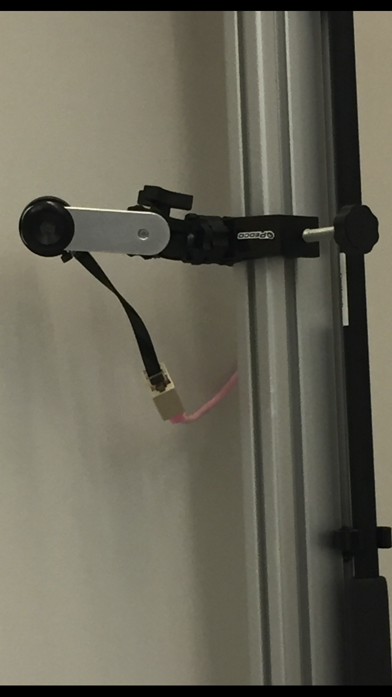

*Figure 7: A Single Pixel Sensor driving Adaptive Mode (circa March 2017)*

*Figure 8: improved setup of entire system (circa March 2017)*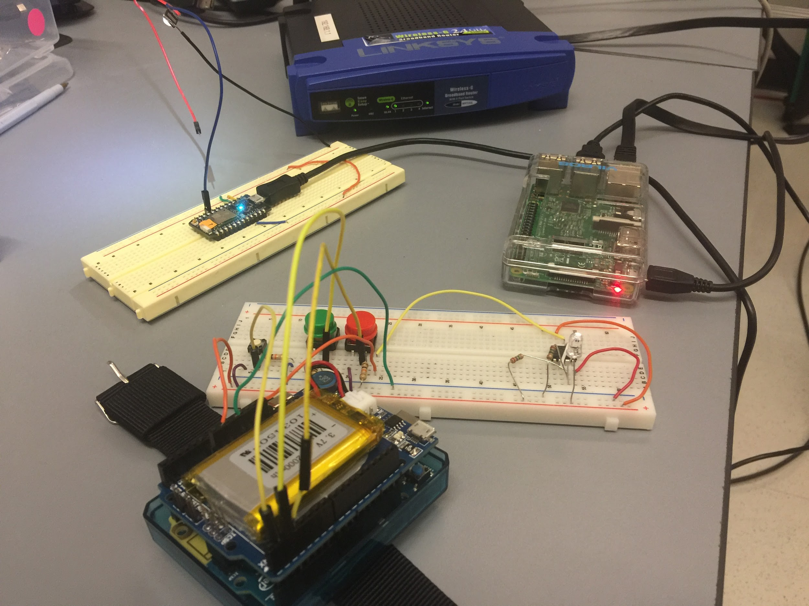

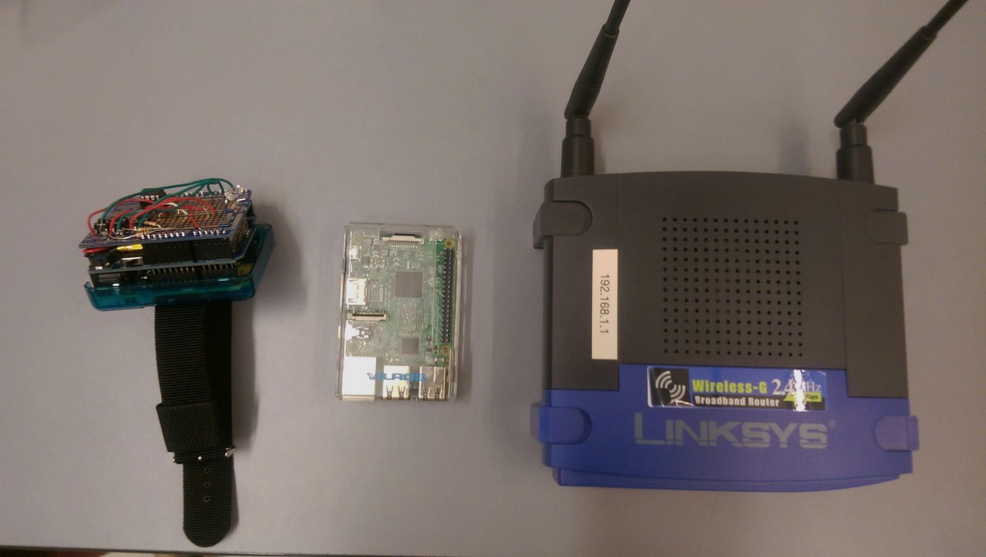

*Figure 9: Final design of Wearable, Central Base and Router (circa April 2017)*

**4.0 Resources**

4.1 **Development Resources**

During development of the hardware components, several sources were consulted, and researched. Some examples include the following:

* <http://wiki.openmusiclabs.com/wiki/FFTFunctions>
* <https://www.arduino.cc/en/tutorial/switch>
* https://www.arduino.cc/en/Tutorial/Genuino101CurieIMUOrientationVisualiser
* <https://docs.particle.io/guide/getting-started/start/photon/>
* <http://www.infoworld.com/article/3176488/linux/a-beginner-s-guide-to-raspberry-pi-3.html>
* <https://www.dexterindustries.com/howto/walk-through-and-tutorial-on-how-to-connect-the-raspberry-pi-and-mobile-phone-connect-raspberry-pi-mobiletablet/>
* https://www.particle.io/products/development-tools/raspberry-pi-on-particle